1. Soil C data was calculated from bulk density and C concentration. Data was from Table 3. (page 276)

The paper does not report carbon density directly. We calculated carbon density from Table 3, which reported bulk density and organic carbon concentration, but not carbon pool.

Soil C pool = Bulk density * Carbon%

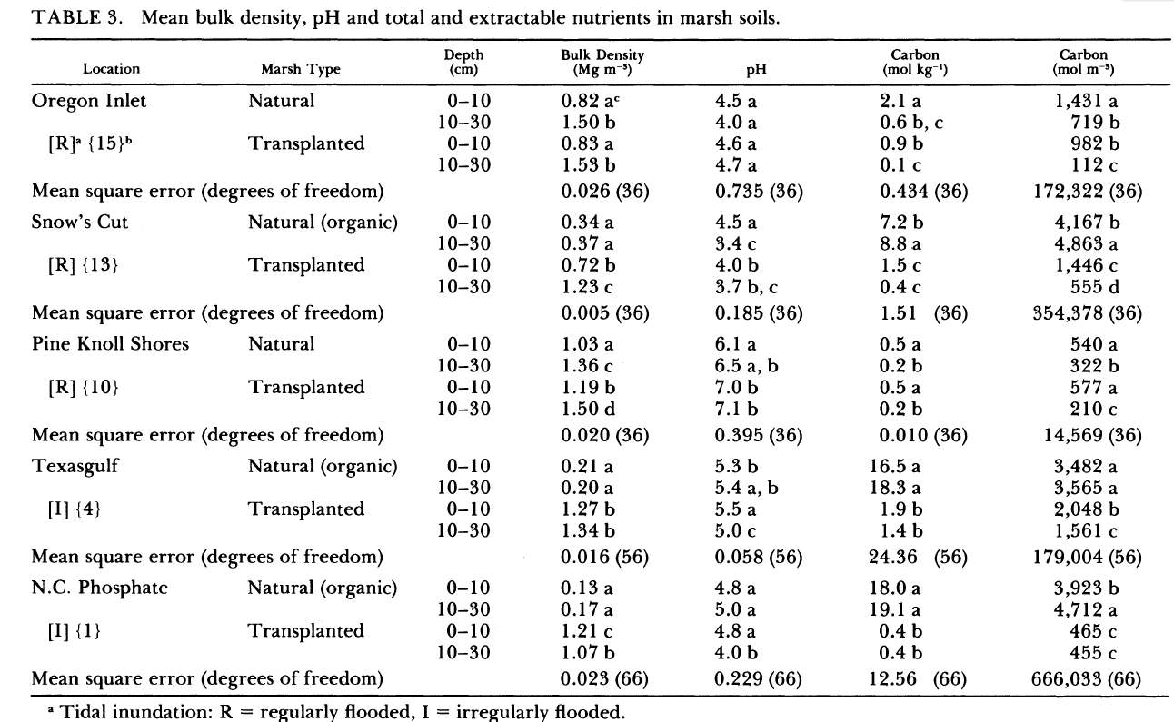

***[Response from Blanca]*** *I already explained in this same Craft paper or another Craft paper how to convert C mol into grams. Then, g/kg = 10*C%; there you have the %C to multiply to BD. There are 5 wetlands, but use only the first 4, the last one is only 1-yr old and is not valid for our study. Take only the Natural values, not the Transplanted. The excel says 30 cm deep so you should take the average of 0-10 and 10-30 data in each.*